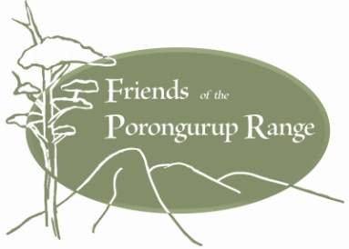
Friends of the Porongurup Range Inc.

ABN 23 239 880 019
PO Box 514
Mt Barker WA 6324
www.porongurup.org.au

MEMBERSHIP APPLICATION FORM

Name ________________________________________________________________________

Address ____________________________________________________________________

Postal address (if applicable) _____________________________________________________

Email address__________________________________________________________________

Phone ____________________ mobile ________________________________

Annual membership:

Single $10.00 _____ Family* $20.00 _____

*Family membership – two votes per family. Eligible for family members under 18 years of age.

Please list family members (if applicable)

___________________________________________________________________________

___________________________________________________________________________

I / we agree to abide by the constitution of the Friends of the Porongurup Range Inc.

Name _______________________________Signed_______________________________

Name_______________________________Signed________________________________

Please return this form to Friends of the Porongurup Range, P O Box 514, Mt Barker WA 6324 or
Email: friends@porongurup.org.au. Direct deposit/ EFT payment to the
Friends of the Porongurup Range, Inc. BSB 633108 account 144 204 047

For office use only

Nominated by …………………………………………… Signed…………………………………………………………

Seconded by ……………………………………………… Signed…………………………………………………………
20150805

